The respective packet size from the NS3 task has been given below: -

1) For 128

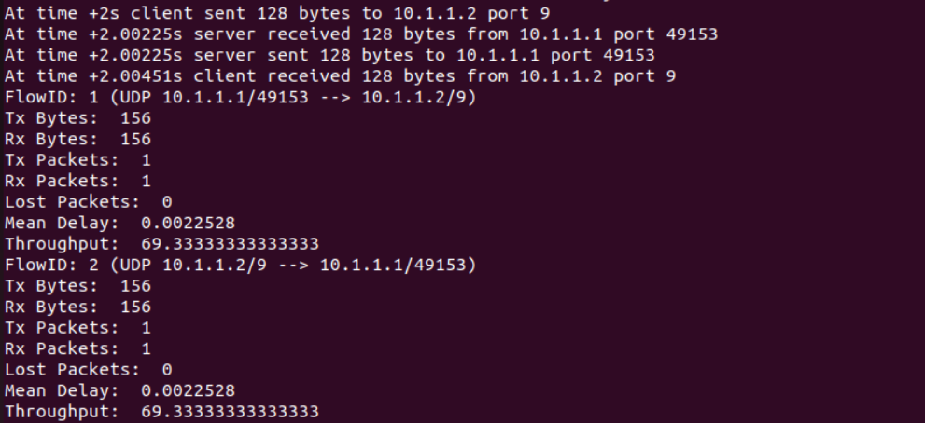

2) For 256

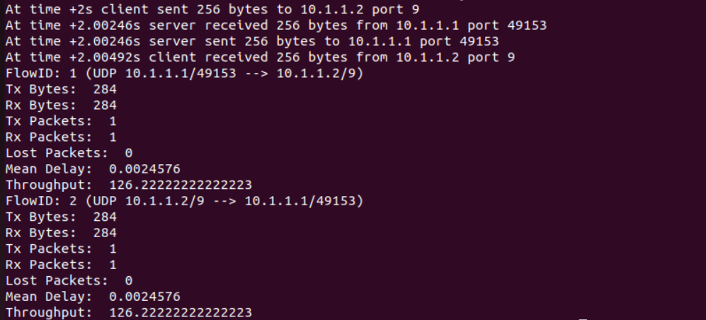

3) For 512

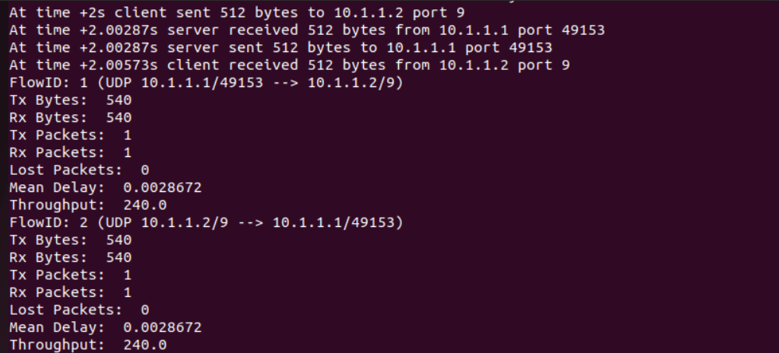

4) For 1024

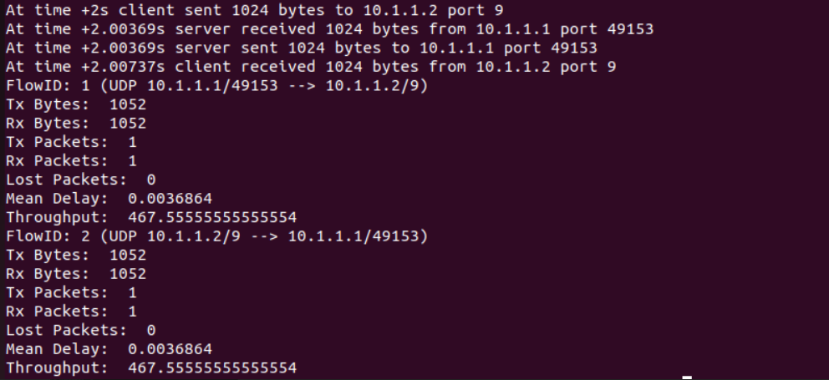

5) For 2048

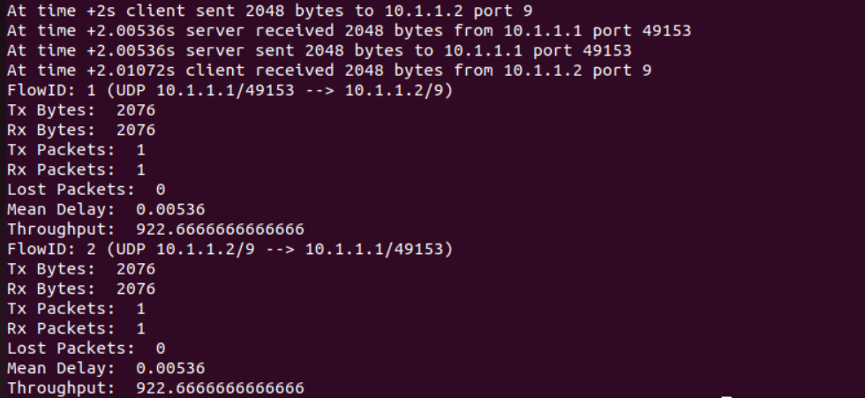

Table:

|  |  |
| --- | --- |
| Packet Size | Throughput |
| 128 | 69.333 |
| 256 | 126.222 |
| 512 | 240 |
| 1024 | 467.555 |
| 2048 | 922.666 |

The graph has been shown below:

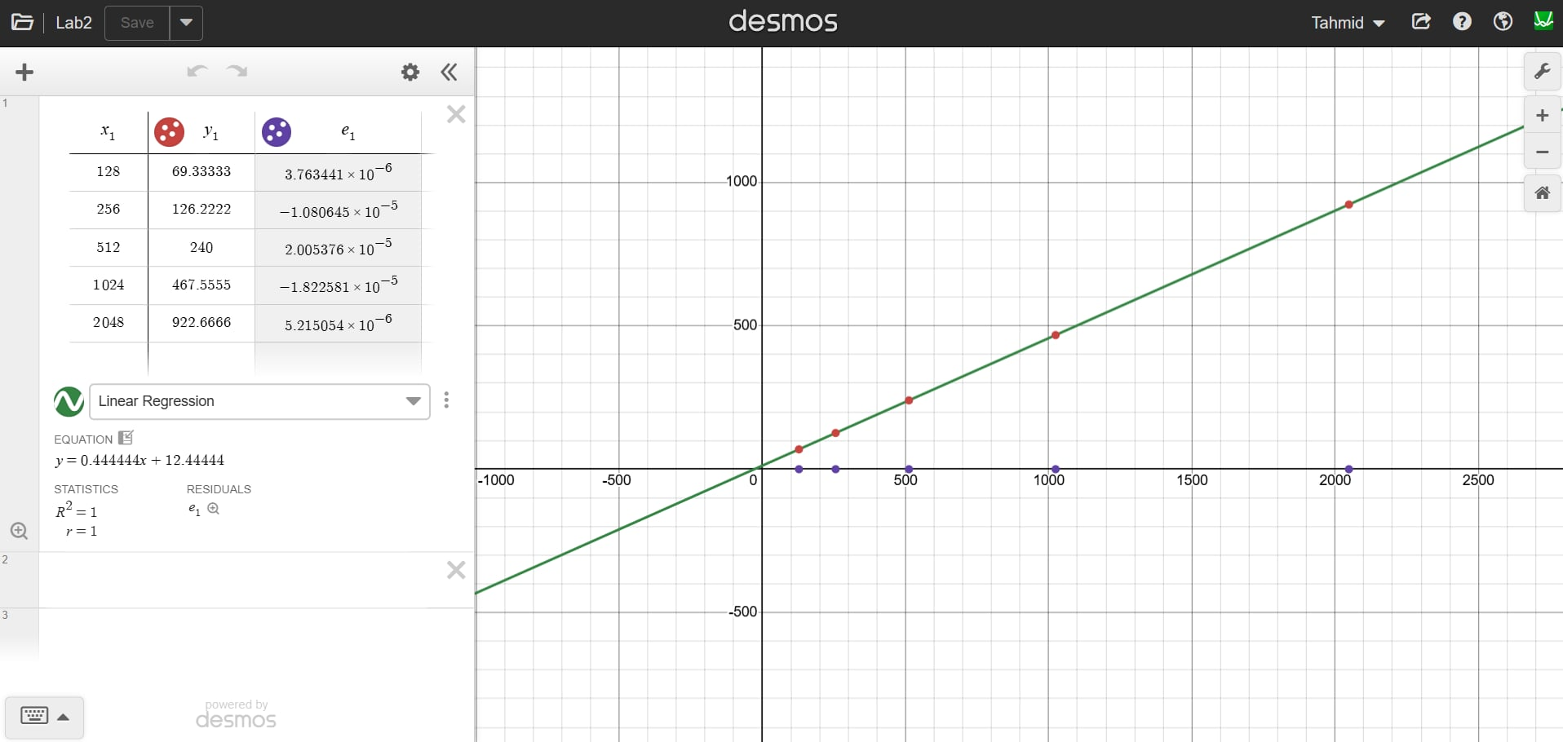

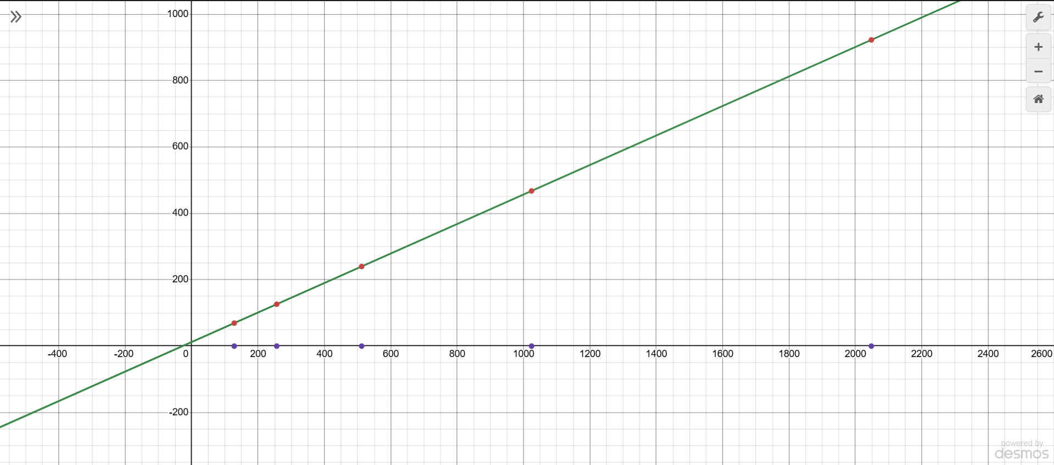

Figure: Packet Size vs Throughput

The above graph shows the X- axis represents the Packet Size and the Y- axis represents the Throughput. The packet data ranges from 128 to 2048, and the throughput value ranges from 69.33 to 922.66. From the graph we can conclude that it is an upward graph with both packet data and throughput values are increasing.